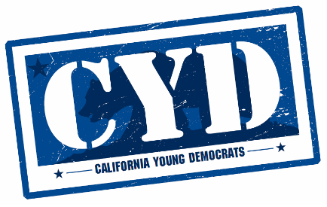

General Session Agenda
Saturday June 1st, 2019 at 6:30pm
Presiding Officer: Will Rodriguez-Kennedy, CYD President

- Call to Order – CYD President – Will Rodriguez-Kennedy 6:30pm
- Roll Call – CYD Secretary Xochitl Medrano 6:31pm – 6:36pm
- Rules Committee Report – Giovanni Chavez 6:36pm – 7:01pm
- New Chapter Roll Call – Xochitl Medrano 7:01pm – 7:05pm
- Officer Reports 7:05pm – 7:15pm
  - President
  - VP of Membership
  - VP of Finance
  - VP of Operations
  - National Committeepersons
- Awards Presentation – Will Rodriguez-Kennedy and Eddie Kirby 7:15pm – 8:00pm
  - Woman of the Year: State Sen. Melissa Hurtado
  - Man of the Year: Ryan Trabuco
  - Outstanding Young Democrats Chapter: Latinx Young Democrats of Orange County
  - Outstanding College Democrats Chapter: Davis College Democrats
  - Outstanding Project: Bakersfield Young Democrats Brain Jam
  - Outstanding Leadership Award: Codi Vierra
  - Roz Wyman Mentor of the Year Award: Crystal Strait
  - Willie Brown Mentor of the Year Award: CA Assembly Majority Whip Todd Gloria
  - Special Award Presentation by Asm. Lorena Gonzalez, Candidate for CA Sec. of State
  - Special Award Presentation by the CYD President

- CYD Political Affairs, Policy and Legislation Report – Crystal Araujo 8:00pm – 8:30pm

- CYD Elections – Eddie Kirby 8:30pm – 8:40pm
  - Note: These offices are uncontested, and the filing deadline has closed.
    - President
    - VP Membership
    - VP Finance
    - VP Operations
    - Secretary
    - Parliamentarian
    - Political Director
    - Communications Director
    - National Committee Person
    - National Committee Person
- Announcements 8:40pm – 8:50pm
  - CYD Academy
  - Unofficial Presidential Straw Poll Results
  - CYD Tahoe Retreat
- Adjourn

HUGE THANK YOU TO OUR SPONSORS!
LYFT
California Lieutenant Governor Eleni Kounalakis
California State Treasurer Fiona Ma
U.S. Representative Eric Swalwell, Candidate for U.S. President
U.S. Representative Barbra Lee
State Assemblymember Evan Low
DNC Member Susie Shannon
State Senator Scott Weiner

Note: Speakers will be attending throughout the meeting and the floor may be yielded by the president to at their discretion.

